How to create an Alma Analytics report of all patrons with expiration date within one week and have active loans | 

Yoel Kortick
Senior Librarian

Question
The library is requesting a report on what they call “IMMINENT LEAVERS HOLDING LOANED MATERIALS”. For example a report of patrons with expiration date within one week and also have active loans? Does Alma have a report like this or can we make one, perhaps in analytics?

Answer
This can be done by using the TIMESTAMPADD parameter in an SQL filter.
For more information on using the TIMESTAMPADD parameter in an SQL filter see separate PowerPoint presentation “How to use the TIMESTAMPADD parameter to retrieve by today - X time in an Alma Analytics report”.

Here are the steps to create the report:

ONE
Create a new analysis in the ‘fulfillment’ subject area. Add the following fields:

"Borrower Details"."Expiry Date"
"Borrower Details"."Primary Identifier"
"Borrower Details"."First Name"
"Borrower Details"."Last Name"

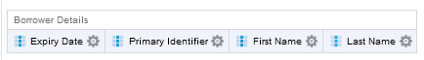

TWO
For clarity purposes rename as follows:
“Expiry Date” to “Borrower Expiry Date”

You can rename by doing “edit formula” and then checking the box “Custom Headings” and putting the new desired heading

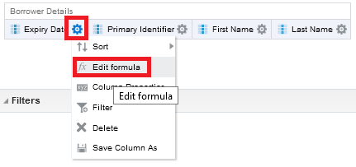

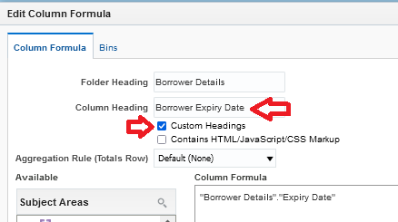

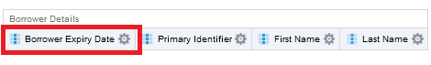

THREE
Make the filters:
Create an SQL TIMESTAMPADD filter on the "Borrower Details"."Expiry Date"using TIMESTAMPADD.

The filter will be:
"Borrower Details"."Expiry Date" BETWEEN (CURRENT_DATE) AND TIMESTAMPADD(SQL_TSI_WEEK, +1, CURRENT_DATE)

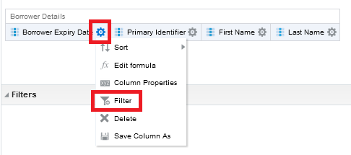

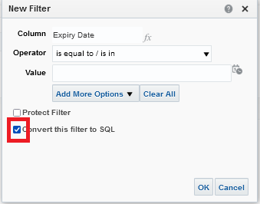

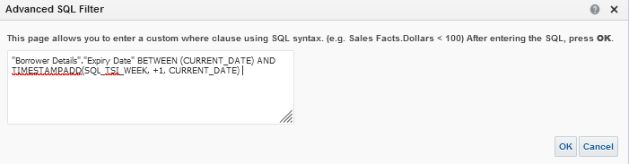

Create an additional filter on the "Loan Details"."Loan Status" so that it is “Active”

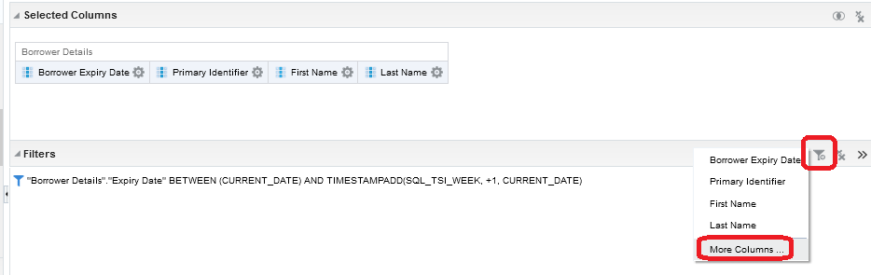

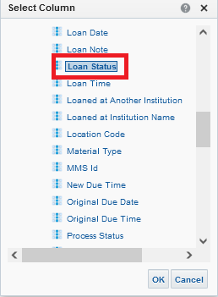

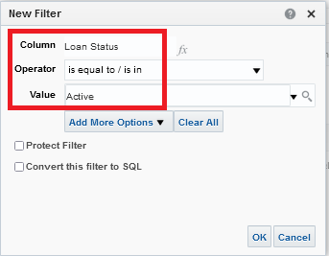

Here are the filters:

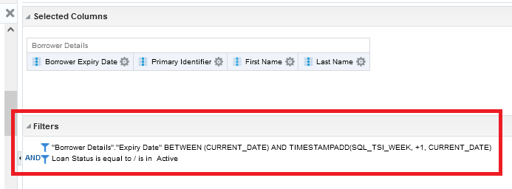

FOUR
See results (run on Oct. 26, 2021):

